For immediate release: March 22, 2018

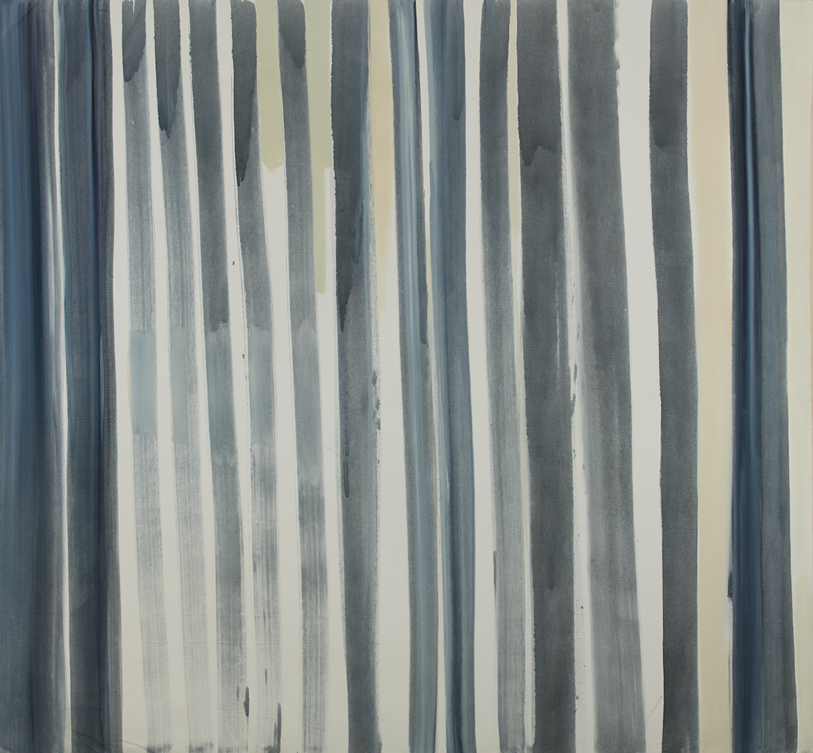
Number 1, 1999, 58 x 62 1/2 in, oil on canvas

Artist Willy Bo Richardson Announces Museum Acquisition, Solo Show at Richard Levy Gallery, Partnership with Designtex

Santa Fe, New Mexico – Noted Santa Fe based painter Willy Bo Richardson’s career is on the precipice of greatness.

On April 10 the Albuquerque Museum of Art and History will be acquiring the first painting of Richardson’s current multi-decade series, Number 1, 1999 for their permanent collection. The museum’s art collection features artists living in or influenced by the region and includes masterworks by Georgia O'Keeffe, Raymond Jonson, Fritz Scholder, and Jaune Quick-to-See Smith.

To celebrate the acquisition, Richardson’s gallery partner, Richard Levy Gallery in Albuquerque, will be hosting a solo exhibition of Richardson’s work, including Number 1. The exhibition titled Navigation will run in the project space April 20 - May 25 with an artist reception on Saturday, May 12 from 6-8 pm.

About the painting Richardson states: My Number 1 was a great intuitive leap against the backdrop of New York intellectualism in the late 90’s which had declared “painting is dead”. I felt like I lived in a culture of no unified tradition for painting, or that the tradition had become the end, or deconstruction of tradition. I simply longed for a system in which I could grow and better myself with the grace and freedom of contemporary thought, while retaining a respect for improving on an objective craft. Craft in this case, being proportion, elements of composition and rules of beauty in their most simplified forms. I needed a first step, a first atomic structure, a first declaration in relation to history and natural wonder. This was my number 1. I had chills of excitement all the while a centered calm while making this painting. I cannot fully express how much joy I felt... like meeting a long-lost family member for the first time.”

Richardson is also excited to announce that his artwork is now available as printed wallcoverings, fabric, and window film through the Designtex Bespoke Portfolio program. Designtex is the leading company in the development, design and manufacturing of applied materials for the built environment. Richardson applies what he’s learned as artist and educator to bringing the creative process to life through everyday environments and commercial products.

Art in commercial and public spaces is often an afterthought and suffers from inattention. Richardson solves this by subtracting the conventional trappings for art, while injecting fine art powerfully into existing commercial contexts. By subtracting the elements of a self-conscious art context, the result is physical space extended in the presence of art, with all the emotional power, but without the frame or the concrete ‘artness.’

A recognized innovator, Designtex is known for their rigorous and dedicated approach to research and development of products with reduced environmental impact. It is a carbon neutral company working internationally with the highest standards. Richardson states, “I have always been an environmentally conscientious person, but when I became sensitized to solvents and chemicals in 2016, safer studio practices and ecofriendly business partnerships became a top priority.”

Willy attributes some of his recent success to his involvement with the Clark Hulings Fund, a Santa Fe and New York City based arts organization that equips professional visual artists to be self-sustaining entrepreneurs. He notes, “The CHF business accelerator program challenged me to get clear about where I want to go creatively and professionally.”

Additionally, he will be part of SITE's Surrealist Drawing Spectacular. On Saturday, April 14 from 3-6pm, Richardson will take part in this popular live drawing event at SITE Santa Fe.

About Willy Bo Richardson

Willy Bo Richardson was born and raised in Santa Fe, New Mexico. He returned to his hometown with his wife after 15 years of being away.

Richardson received an MFA from Pratt Institute in 2000. In 2011 his work was included in “70 Years of Abstract Painting” at Jason McCoy Gallery in New York, which assembled works by modern and contemporary painters, including Josef Albers, Hans Hofmann and Jackson Pollock. He was honored to be one of eight SITE Santa Fe SPREAD finalists in 2014. His work and vision was featured on the PBS weekly arts series ¡COLORES! and featured in New Mexico Magazine’s April 2018 issue.

Richard Levy Gallery wrote: “Richardson stretches vertical bands of color so intense across each canvas that they seem to crackle like neon. Gripping the viewer, a humming field suspends the sensation of time. He has described his act of painting as a sort of meditation, a give-and-take with gravity and the universal laws that determine our experience of the physical world.”

# # #

For more information please visit https://willyborichardson.com/. For press needs please contact Willy Bo Richardson on (505) 603-5953 or w@willyborichardson.com.
For Richard Levy Gallery info see http://www.levygallery.com/ or contact gallery director Viviette Hunt on viviette@levygallery.com or 505.766.9888. For information on the Clark Hulings Fund, please see https://clarkhulingsfund.org or contact Susan von Seggern on susan.von.seggern@clarkhulingsfund.org or 213-840-0077.

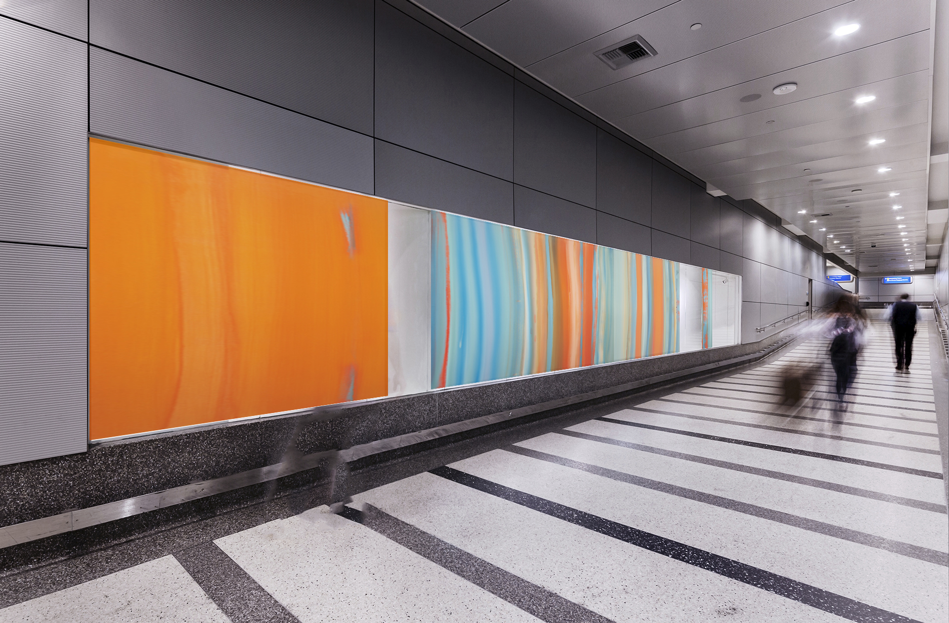
concept sketch for digitally printed ceramic steel panels offered through Designtex,
Willy Bo Richardson Music to Drive To

